FRAMEWORK BRIEF · PUBLIC EDUCATION AND NARRATIVE INFRASTRUCTURE
Show Us a Budget and We'll Show You a Values System
A framework and worksheet for translating policy choices into values arguments
mBOLDen Change · mboldenchange.org

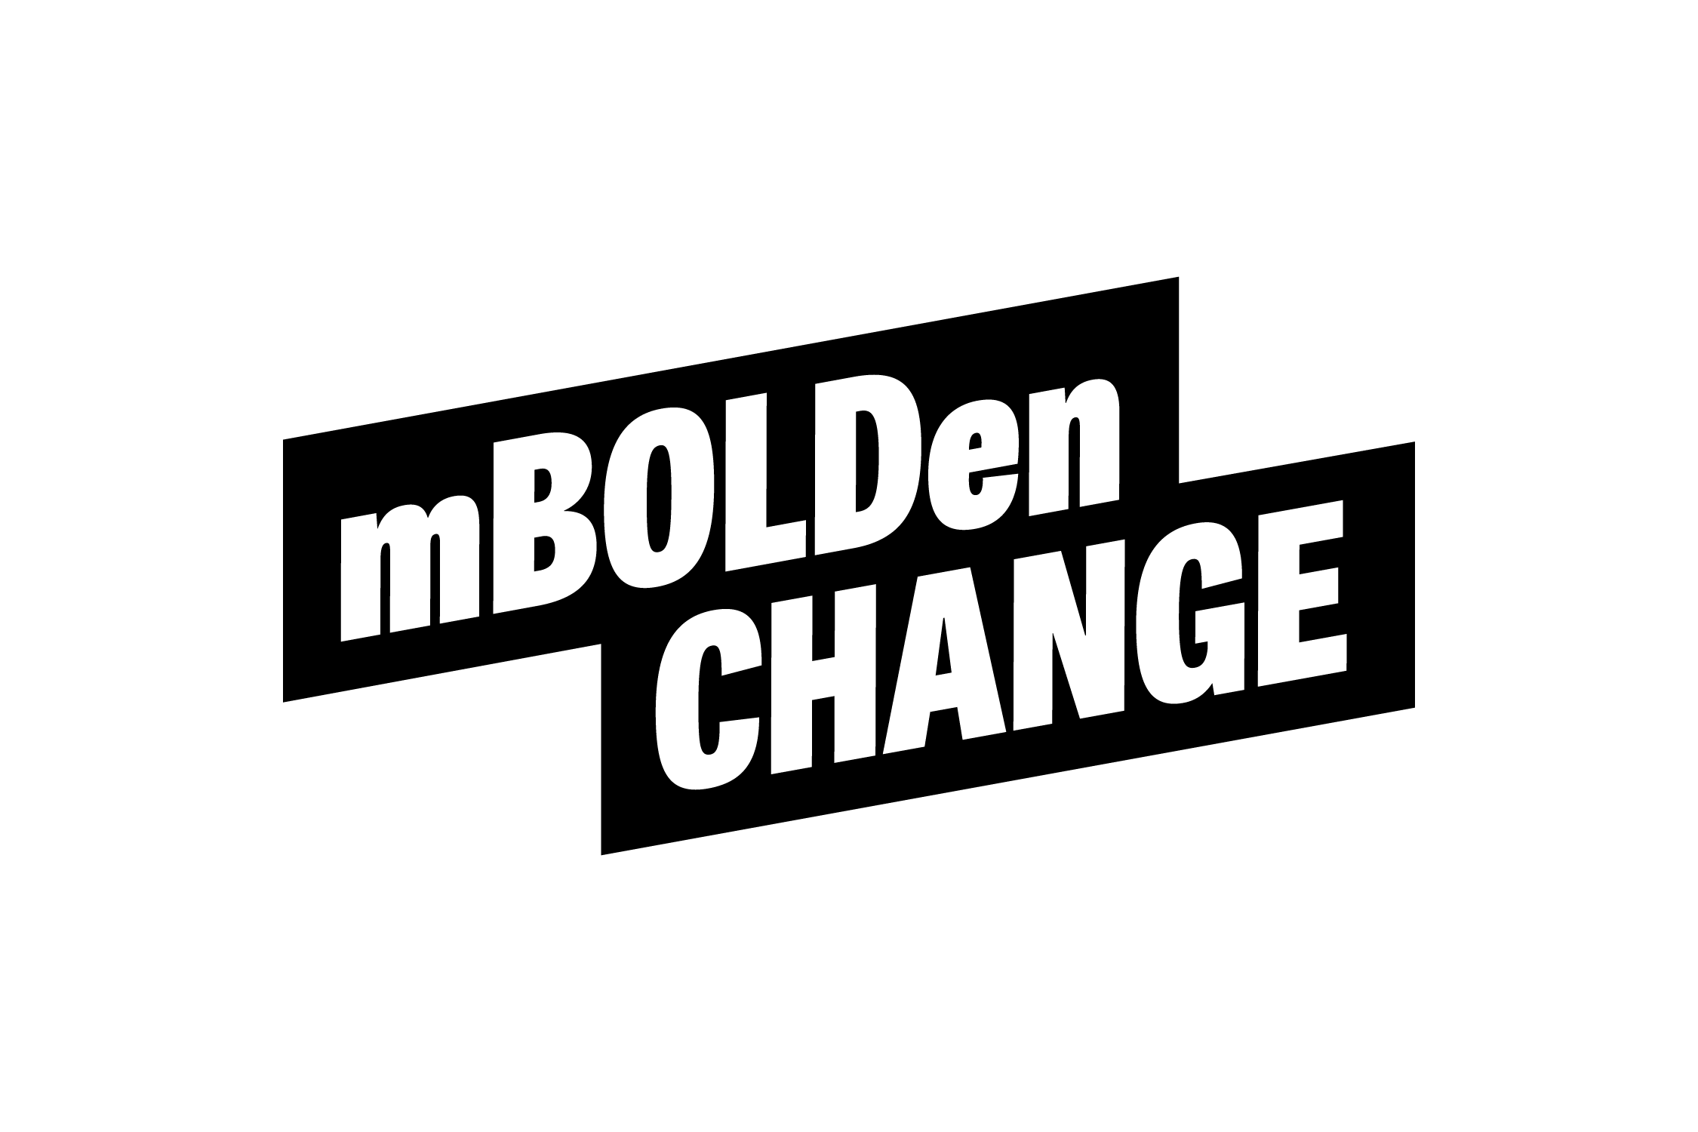
Every policy fight is a values fight. Most campaigns never get there. They argue the mechanics — the size of a cut, the details of a regulation, the cost of a bill — and lose before the real argument starts.
This framework starts somewhere else: concrete choices reveal actual values. Not the values we claim. The values embedded in what we fund, who we protect, and what we let slide. A budget is a values statement. So is a zoning code, a sentencing guideline, a subsidy. Show us the choice and we’ll show you the values.
The worksheet below is the tool. Use it to move any campaign from a technical policy debate to a human values argument.

The Values Translator

Step 1: The Cold, Hard Choice
Identify one specific, concrete policy choice — a budget line, a zoning code, a subsidy, a regulation.
The Choice: ________________________________________________________

Step 2: The Human Trace
Trace that choice to its human cost. Who does this decision expose? What does it cost a specific family — in dollars, in decisions, in consequences?
Who is affected? ________________________________________________
What is the real-world consequence? ________________________________

Step 3: The Reveal
What does this choice say about who matters? Name the value the policy actually reinforces — not the one in the mission statement, but the one embedded in the funding.
The Stated Value: _______________________________________________
The Revealed Value: ______________________________________________

Step 4: The Invitation
Shift from implication to invitation. Not guilt — a different collective choice.
The Pivot: “Instead of choosing [Revealed Value], we can choose to build [New Vision].”
The Call to Action: _____________________________________________

Translation Examples
Use these as a guide. The policy choice changes. The translation method does not.
The Policy Choice | The Human Cost | The Revealed Value
Healthcare consolidation | A family pays $27K in premiums with a $6K deductible. The nearest hospital raised prices 3.6% — there’s no competition left. | We value industry profit margins over human survival.
Medicaid cuts | A rural hospital closes. The nearest ER is now 45 minutes away. A neighbor’s ambulance ride costs more than a month’s rent. | We value deficit reduction over whether people survive emergencies.
SNAP cuts | A 62-year-old school bus driver loses food assistance. She chooses between blood pressure medication and a full week of meals. | We value fiscal discipline over whether seniors eat.
Housing costs | A credentialed teacher cannot afford to buy a home in the district she serves. An algorithm told every major landlord in her zip code to raise rents simultaneously. | We value property appreciation and investor returns over community stability.
Childcare costs | A two-income household pays $26K/year in childcare. The second income nets $3/hour after childcare, taxes, and commuting. The “choice” to stay home is math, not preference. | We value workforce participation in theory but refuse to fund the infrastructure that makes it possible.
Education funding | A high school loses three math teachers in two years. A kid 20 minutes away stocks shelves at $17/hour instead of studying engineering. Pell Grants cover 27% of tuition today; they covered 80% in 1975. | We value the zip code you were born in over your right to thrive.
Tax policy | A billionaire’s effective tax rate is lower than a firefighter’s. The $606B annual tax gap is backfilled with cuts to services the firefighter’s family uses. | We value wealth preservation over shared investment.
Energy subsidies | Fossil fuels get $35B/year in federal subsidies while solar is 41% cheaper. Low-income households carry 3x the energy burden. The industry spent $219M to influence the 2024 election. | We value fossil fuel shareholder returns over breathable air and stable energy costs.
Immigration enforcement | ICE budget jumps 400% in one year. A parent detained during a traffic stop. Children placed in temporary custody. The family had been here 14 years. | We value enforcement theater over family stability.
Zoning restrictions | A tech campus approved for 25,000 workers; only 7,000 housing units approved nearby. Home prices within commuting distance jump 7%. The people who built the community can no longer afford it. | We value corporate expansion over the communities that absorb its costs.

The mBOLDen Reminder
Guilt closes people down.
Implication and invitation open them up.
Culture change is slow, intentional, and possible.
Developed by mBOLDen Change in partnership with the Economic Security Project’s Affordability Campaign Collaborative.
Free to use, adapt, and brand as your own.

mBOLDen Change · mboldenchange.org · mboldenaction.org · Fueling what works. Fighting for what’s needed.

